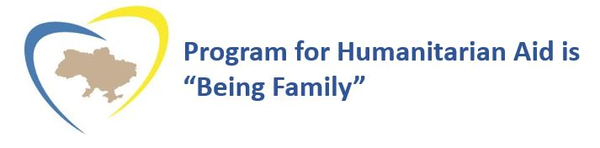

Suggested Bequest Language

The following language may aid you and your attorney in preparing your bequest to Program for Humanitarian Aid.
I hereby give, devise and bequeath (specific asset; dollar amount; % of estate; etc.) to Program for Humanitarian Aid, a nonprofit organization located in Texas, Federal Tax ID #26-3427030, for Program for Humanitarian Aid’s general use and purpose.

Suggested Beneficiary Language

Insurance and Retirement Accounts
Program for Humanitarian Aid Tax ID# 26-3427030
PO Box 12087
College Station, TX 77842

Program for Humanitarian Aid
PO Box 12087, College Station, TX 77842
(979) 220-5691
ProgramForHumanitarianAid.org

